25th Annual Taste of the Valley
TO SUPPORT
Bearcamp Valley School & Children’s Center
Sunday June 11th, 2017
First Seating Second Seating
4:30 – 6:00 6:00 – 7:30
Hosted by Hobb’s Tavern & Brewing Co.
For tickets: Contact Molly Ricker at Bearcamp Valley School (603) 323-8300 or online at Taste of the Valley on www.eventbrite.com
Featuring:
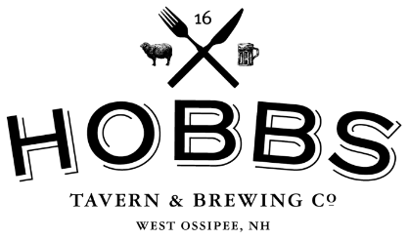
Jonathan’s Seafood • Songbird
Scandinavian Bakery •Daley Café
Whittier Lion’s Club •River’s Edge
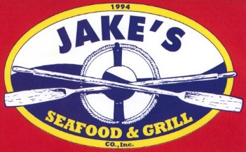
Café Noche •Tamworth Camping Area
Corner House Inn • & more!

